**Wireframe Document**

**Analyse International Debt Statistics**



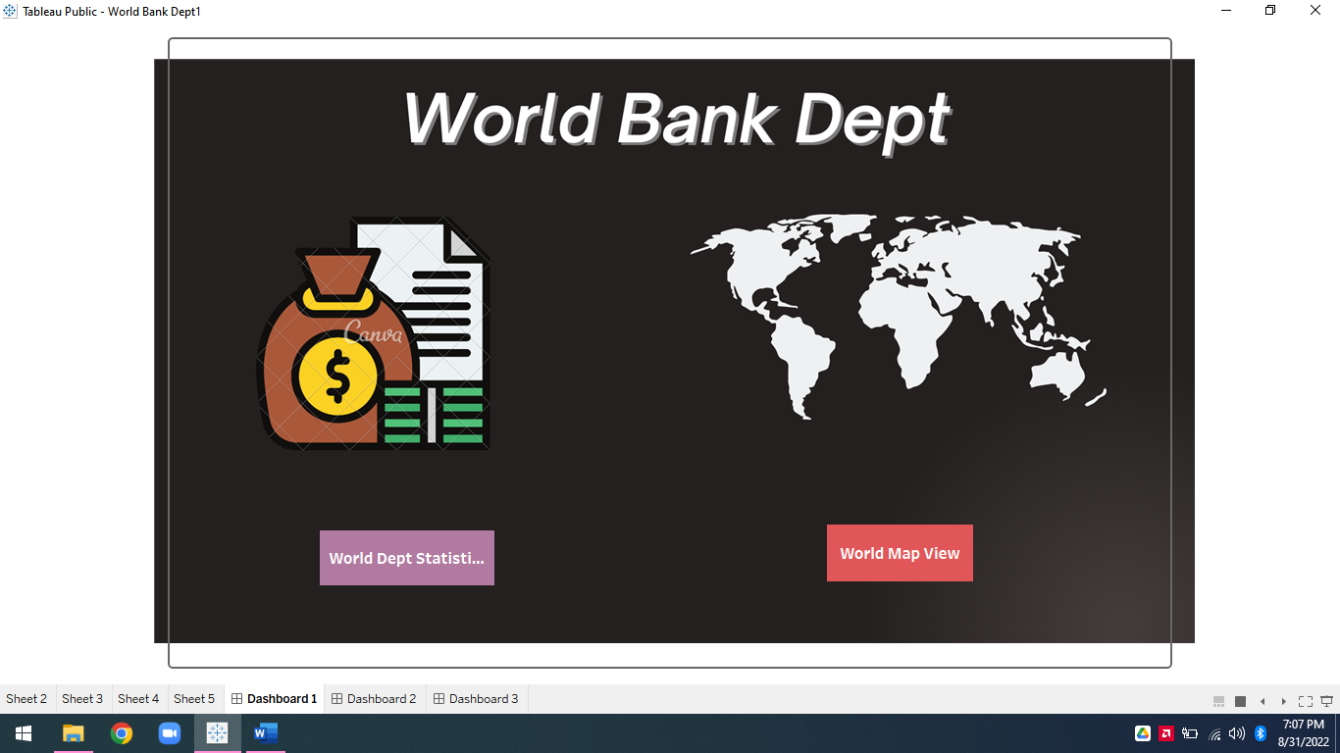

**Revision Number - 1.0**

**Last Date of Revision - 31/08/2022**

**Syed Ameer John SK**

WIREFRAME DOCUMENT DESIGN

**Document Control**

|  |  |  |  |
| --- | --- | --- | --- |
| **Date** | **Version** | **Description** | **Author** |
|  |  |  |  |
| 31/07/2022 | 1.0 | Introduction, | Syed Ameer John SK |
|  |  | Problem Statement |  |
|  |  |  |  |
| 31/07/2022 | 1.0 | Dataset Information, | Syed Ameer John SK |
|  |  | Architecture |  |
|  |  | Description |  |
|  |  |  |  |
| 31/08/2022 | 1.0 | Final Revision | Syed Ameer John SK |
|  |  |  |  |

WIREFRAME DOCUMENT DESIGN

**We Performed Exploratory Data Analysis on Jupyter Notebook and then created a Tableau Desktop Dashboard.**

**Task:**

**1.** **Finding the number of distinct countries?**

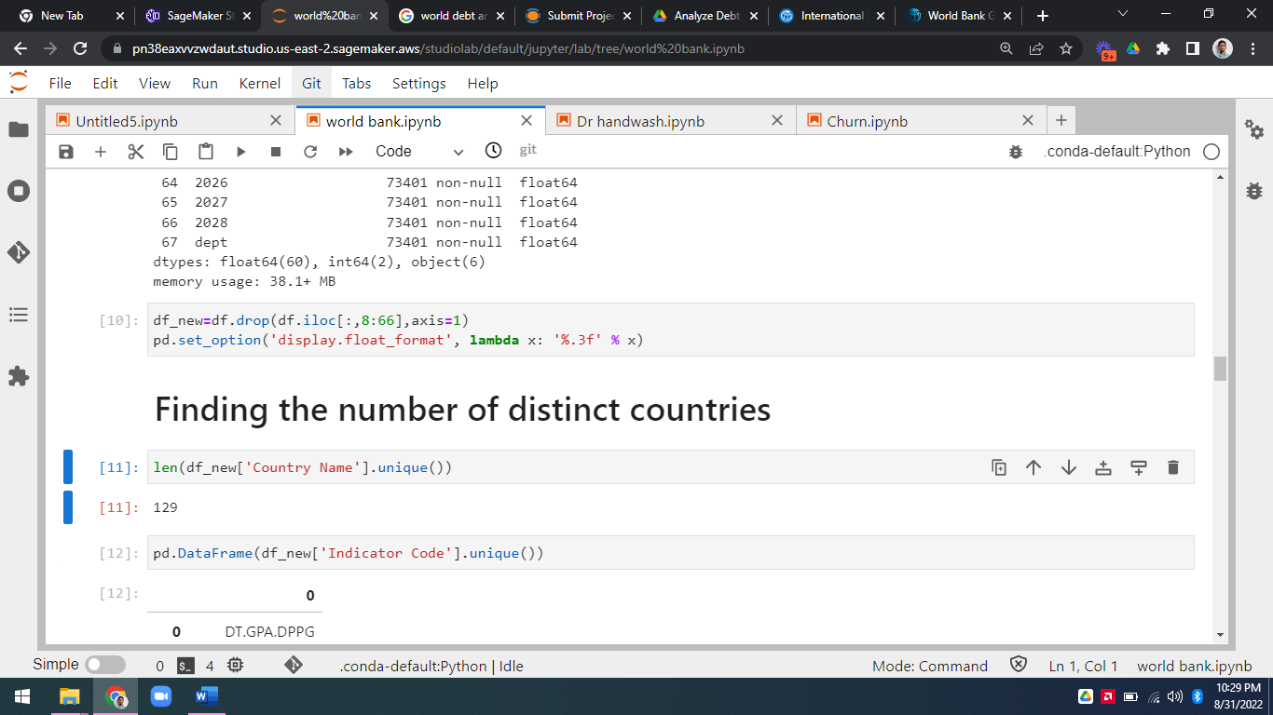

128 Unique Country

**2.** **Finding out the distinct debt indicators?**

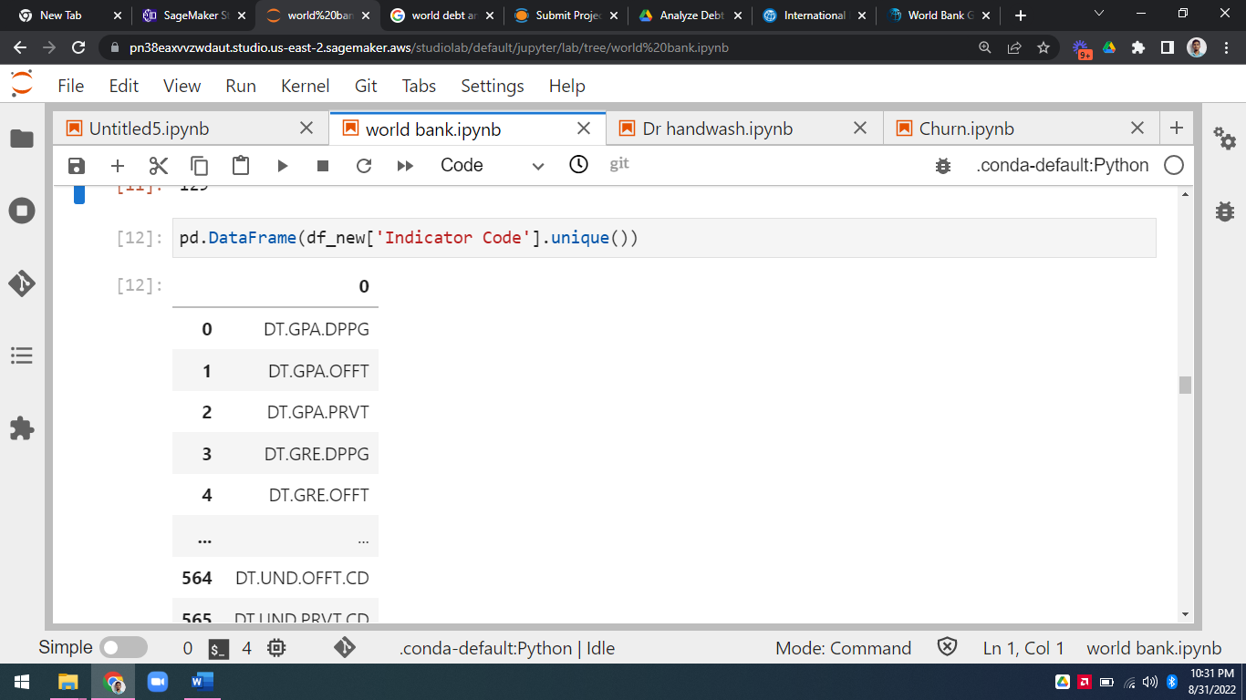

569 Distinct Indicators

**3.** **Totaling the amount of debt owed by the countries?**



**3.** **Country with the highest debt?**

**4.** **Country with the highest debt?**

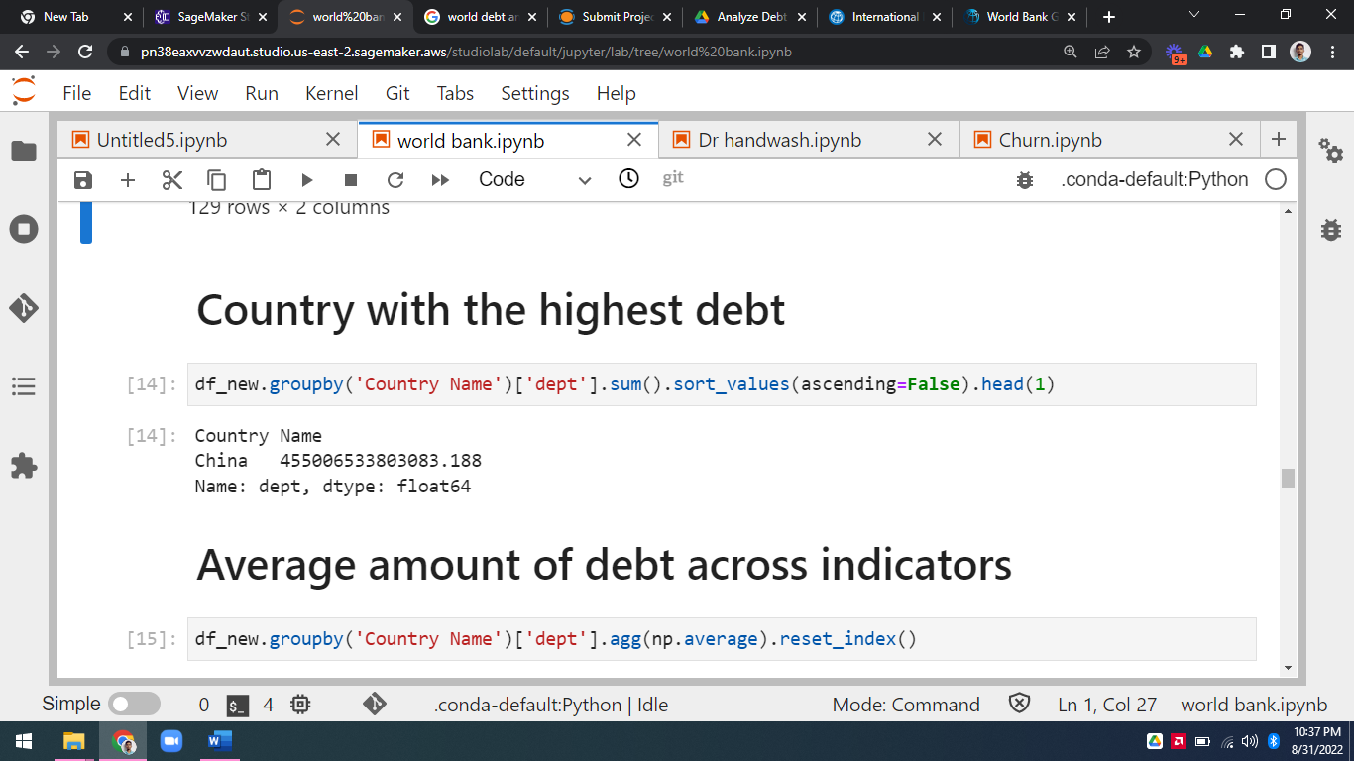

China

**5. Average amount of debt across indicators?**

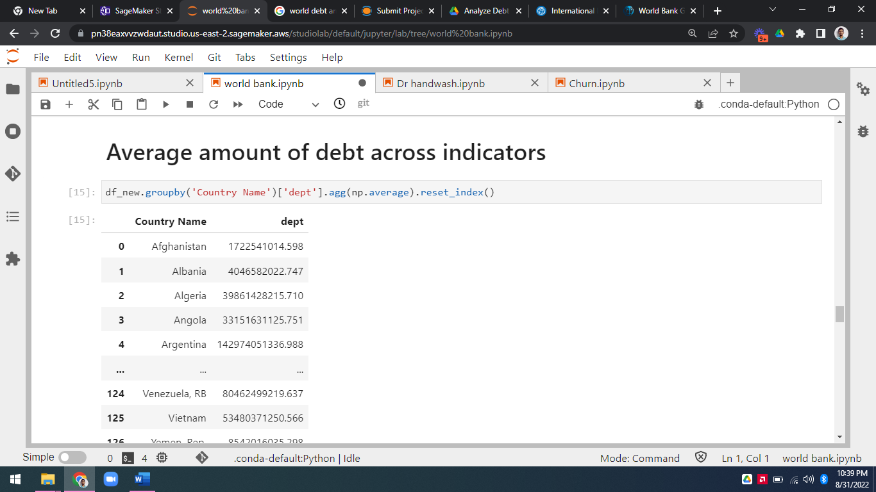

**6.** **The highest amount of principal repayments?**

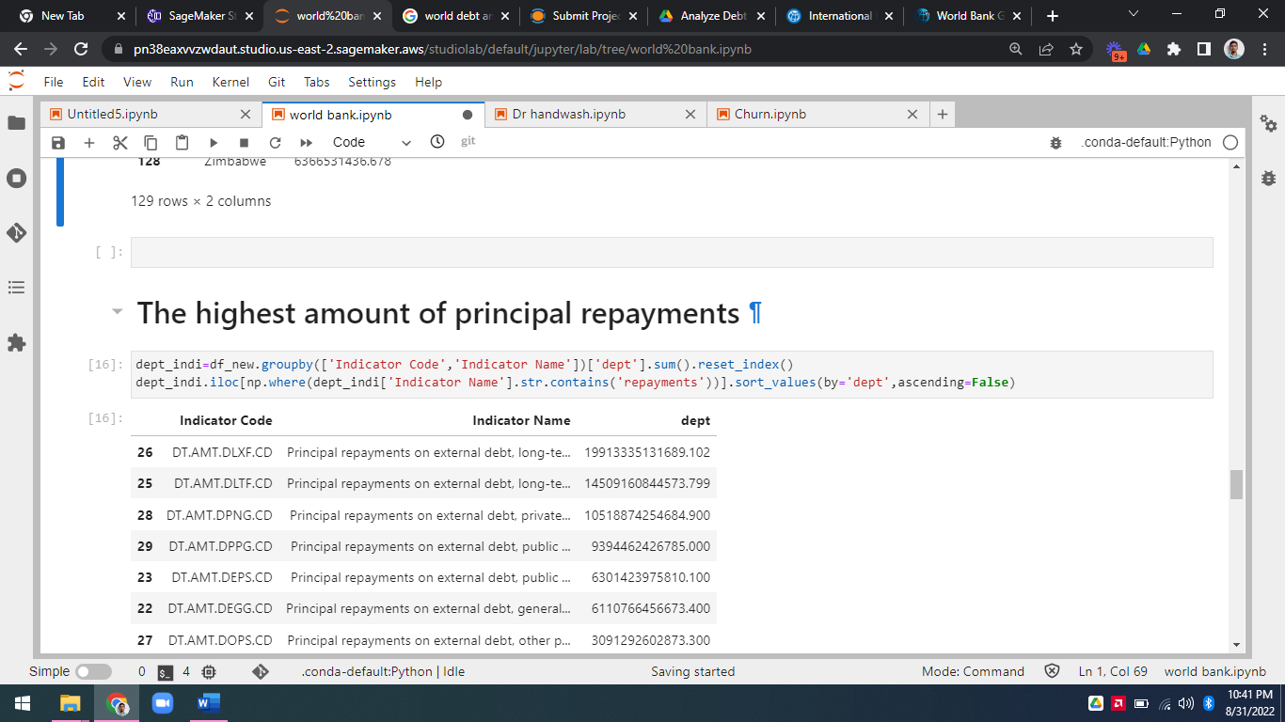

**6.** **The most common debt indicator?**

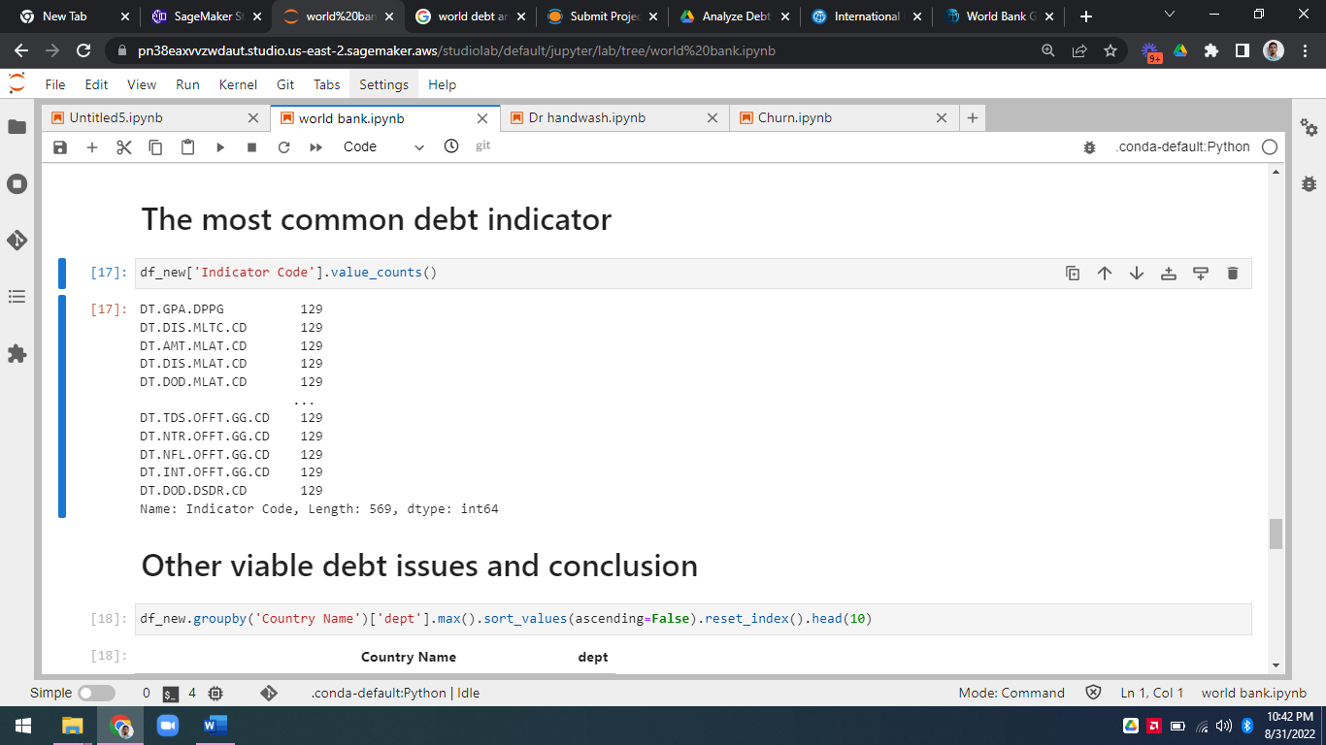

**7.** **Other viable debt issues and conclusion?**

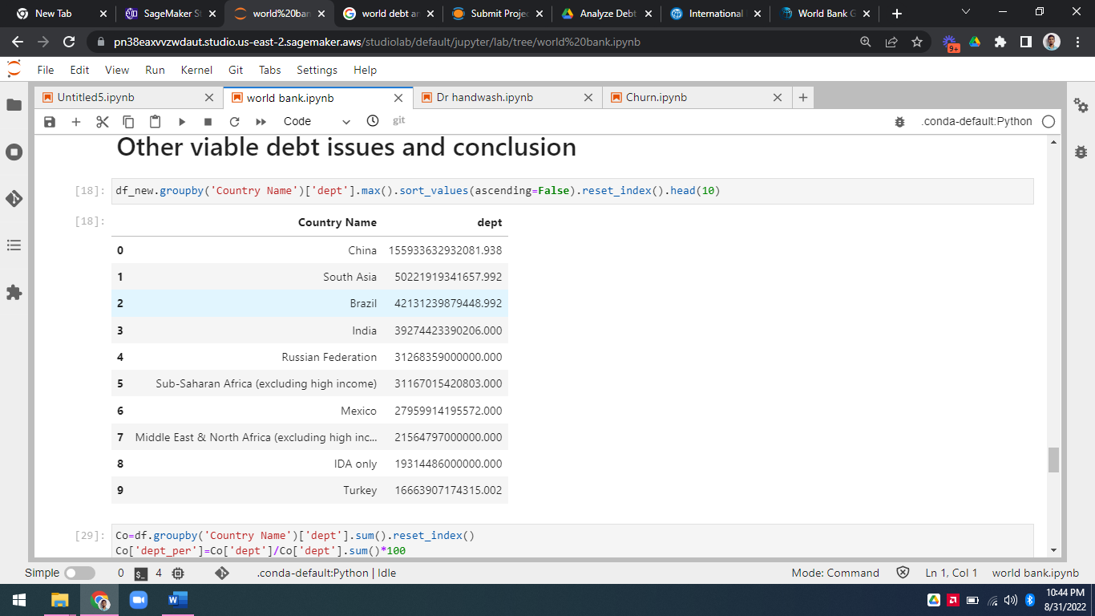



* Total 1st Country with high Dept is China
* All Country Have Same 129 Dept Indicators
* This Indicator DT.AMT.DLXF.CD Having highest amount of principal repayments
* 128 Unique Country’s present in the Dept Analysis
* 569 Distinct Indicators and Indicator Name for Dept
* China Dept is 13.102% Over all World Country’s